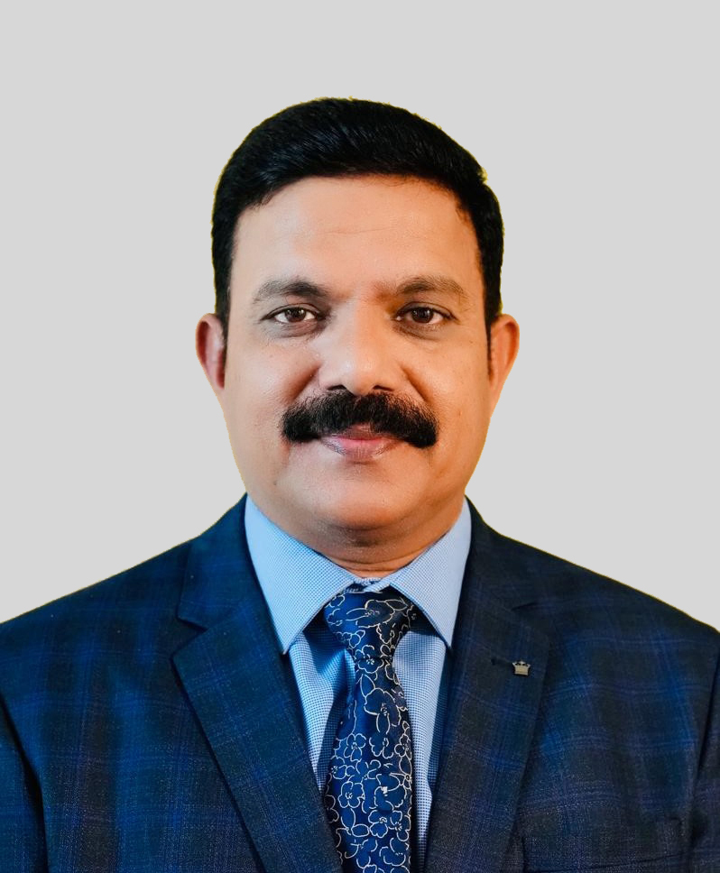
Brief Bio-data

Name: Dr Satya Nand Sushil

Designation: Director

Present Address: ICAR-National Bureau of Agricultural Insect Resources, Bengaluru-560024 INDIA

Contact Details: Phone: 080-23414220, 23412983 (o); Mobile: +91-9910558766
E-mail: director.nbair@icar.gov.in; satya.sushil@icar.gov.in; snsushil@yahoo.co.uk

Field of Specialization: Biological Control, IPM, Biosystematics, Lac Culture, Apiculture, Plant Quarantine, Invasive Pest Management, Plant Protection Regulations & Policies

Education: M.Sc (Agril. Entomology) & Ph.D. (Agril. Entomology)- from GBPUA&T, Pantnagar, India

Professional Career: 1993-Scientist, ICAR-NAARM, Hyderabad
1994-Scientist, ICAR-IIHR, Bangalore
1994-2002-Scientist, ICAR-ILRI (Now NISA), Ranchi
2002-2009-Senior Scientist, ICAR-VPKAS, Almora
2009-2013-Principal Scientist, ICAR- IISR, Lucknow
2013-2016 - Plant Protection Adviser, Govt of India, New Delhi
(On deputation selected through UPSC)
2016-2022 – Principal Scientist, ICAR-IISR, Lucknow
2022- Till date- Director, ICAR-NBAIR, Bengaluru

Patents: 02 (granted)
- Patent No: 290170 (Govt. of India) for 20 years from 15.11.2007 (date of grant 30.11.2017) for invention entitled “An insect trapping device”.
- Patent No. 336230 (Govt. of India) for 20 years from 08.07.2008 (date of grant 29.04.2020) for invention entitled “A process for mass production of Bacillus thuringiensis (Bt) biocide using millet grain based agro-medium”.
No. of technologies developed: 20
No. of technologies commercialized: 06

Prominent Awards:
- WIPO Gold Medal-2008 by World Intellectual Property Organization, Geneva (United Nations Organization)-as Team Leader
- Societal Innovation Award-2008 by NRDC, New Delhi, Ministry of Science & Technology, Govt. of India. The award included a cash prize of Rs. 3.0 lakh and citation.- as Team Leader
- ICAR Award for Outstanding Interdisciplinary Team Research in Agriculture and Allied Sciences for the Biennium 2005-06.- as Team Member
- Outstanding Scientist Award-2009 by Uttarakhand Organic Commodity Board, Dehradun, Uttarakhand.
- Certificate of Appreciation awarded in 2014 for excellent contribution to Plant Quarantine by ICAR-NBAIR and Society for Biocontrol Advancement, Bangalore.
- Certificate of Appreciation awarded in 2016 for distinguished contribution to the farmers’ welfare by Federation of Indian Chambers of Commerce & Industry (FICCI).
- Outstanding Agricultural Scientist Award-2020 by Dr B.V. David Foundation for commendable contribution to agricultural entomology and plant protection.
- Certificate of Appreciation awarded in 2022 by USDA-Foreign Agricultural Service for delivering a successful Phytosanitary Training to the officers of Plant Quarantine, Govt. of Bangladesh and other stakeholders supported by USDA-FAS and USAID on June 17, 2022 at Dhaka, Bangladesh.
- Insect Environmentalist Outstanding Achiever Award-2022 by Insect Environment journal on its silver jubilee celebration on December 17, 2022 at Bengaluru.
- Global Biopesticides Excellency Award-2023 by AMMA, India and Ministry of Agriculture of Kyrgyz Republic on August 27, 2023 at Bishkek, Kyrgyzstan.
- Golden Jubilee Special Award-2023 by Plant Protection Association of India on Nov 15, 2023 at Hyderabad.

Fellowship of the Professional Societies: 05 (FNAAS, FESI, FSBA, FAZRA, FSSRP)

Chairman/ Member of important national level committees
- Chairman, FAD 01 committee on Pesticides, Bureau of Indian Standards, Govt. of India (Ex-officio Chairman as Plant Protection Advisor to Govt. of India)-(2013-2016).
- Member, Registration Committee for Pesticides, Govt. of India -(2013-2016).
- Member, Central Insecticide Board, Govt. of India -(2013-2016).
- Member, Genetic Engineering Appraisal Committee (GEAC), Govt. of India (Ex-officio Member as PPA to Govt. of India)-(2013-2016).
- Chairman, Expert Group on “Harmonization of data of bio-pesticides of already registered strains” constituted by Registration Committee of Pesticides, Govt. of India-(2014-2015).
- Chairman, Expert Group for review of various guidelines of registration of insecticides by the Registration Committee, Govt. of India-(2014).
- Chairman, Committee for assessment of whitefly problem in Punjab in 2016. The committee was constituted by the Govt. of India.
- Member, National Committee on Crop Grouping. The committee was constituted by the Govt. of India.

Chairman/ Member of International delegation:
- As member of Indian delegation, attended 28th session of APPPC from 22nd to 29th September, 2013 held at Jeju Island, Korea.
- As member of Indian delegation, attended India-Australia joint working group on cooperation in Agriculture and plant technical meeting from 20th to 27th November, 2013 held at Melbourne and Canberra, Australia.
- As member of Indian delegation, attended the 9th Session of the Commission on Phytosanitary Measures from 31st March to 4th April, 2014 held at FAO, Rome, Italy.
- As leader of Indian delegation, attended the 10th Session of the Commission on Phytosanitary Measures on March 16-20, 2015 held at FAO, Rome, Italy.
- As leader of Indian delegation, attended the 11th Session of the Commission on Phytosanitary Measures on April 4-8, 2016 held at FAO, Rome, Italy.
- As leader of Indian delegation, attended SATNET Asia Inter-regional visit and workshop on Agricultural Trade Facilitation during September 23-26, 2014 held at Bangkok, Thailand.
- As member of Indian delegation, attended India-South Africa joint working group on cooperation in Agriculture from June 1-3, 2015 held at Pretoria, South Africa.
- As International Expert imparted SPS training on ‘Improving phytosanitary trade compliance in Bangladesh” organized by APAARI & USDA for PPQ officials of Bangladesh Government at Dhaka, Bangladesh in June 2022 and Bangkok, Thailand in September, 2022.
- As ‘Technical Expert’ represented Govt. of India at ‘Global Forum on Biological Control’ and training workshop on biological control organized by FAO at ICIPE, Nairobi, Kenya during June 26-30, 2023.
- As ‘Expert Panelist’ attended ‘Global Biopesticides Summit-2023’ on August 2023 at Bishkek, Kyrgyzstan.

Publications: Total: 449
- Research papers: 125 [In NAAS rated peer reviewed journals]
- Research papers presented in symposiums/ seminars: 64
- Books: 20
- Book chapters: 11
- Research/ Extension bulletins/ Manuals etc.: 123
- Extension leaflets/Folders/ Popular articles: 65
- TV/ Radio talks: 41

Visits Abroad:
- Attended 15 international conventions/ meetings/ workshop as member/team leader of Indian delegation.

