18BUCURRICULUM – VITAE


1. Name : DR. S.V. SATYANARAYANA RAJU

2. Present Position : Director, Institute of Agricultural Sciences,
Banaras Hindu University, Varanasi
Head & Professor of Entomology

3. Father’s Name : Dr. S.V. Subba Raju

4. Address for : Department of Entomology,
Correspondence Institute of Agricultural Sciences,
Banaras Hindu University
Varanasi -221005, India
E-mail: svsraju_bhu@yahoo.com
Phone: +91-542-2575822 (R)
Fax: +91-542-2368993
Mobile: +91-9451721177
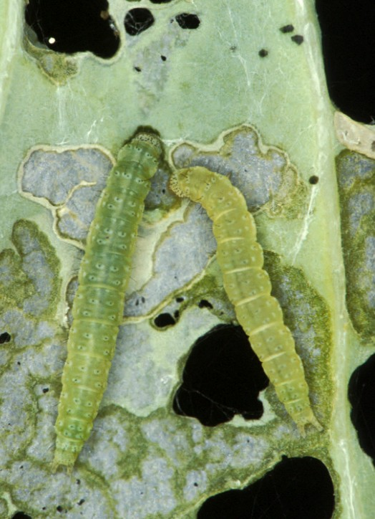
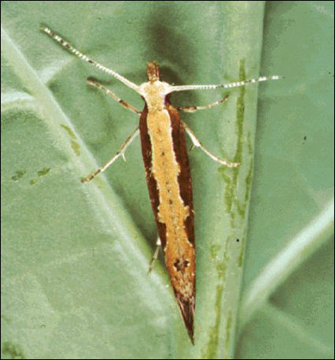
5. Date of Birth : 10th-July, 1962

6. Nationality : Indian

7. Marital Status : Married

8. UAwards

UProfessional
- “Best Institutional Award – 2024” conferred by Indian Council of Agricultural Resarch and Association of Indian Agricultural Students Association, New Delhi
- “Life time Achievement Award - 2023”conferred by Himachal Pradesh University and Agricultural Technology Development Society, Ghaziabad.
- “Mahima Fellow of Society Award – 2022” conferred by Mahima Research Foundation and Social Welfare, Varanasi
- “Outstanding Achievement Award - 2021”conferred by Jaipur National University and Agricultural Technology Development Society, Ghaziabad.
- “T. B. Fletcher Memorial Award – 2020” conferred by Dr. B. Vasantharaj David Foundation, 76/2A Sree Ramulu Street, Madanadapuram, Chennai
- ‘Distinguished Scientist Award – 2020’ conferred by Green Agri Professional Society, Dhanbad, Jharkhand
- ‘SPS India Fellow’ conferred by Society of Pesticide Science, Division of Agrochemicals, IARI-ICAR, New Delhi India, 2019.
- ‘Agriculturist Achievement Award- 2019’conferred by University of Allahabad FRCER & RSKSEPS, Prayagraj.
- Dr. Anand Prakash Award-2018’ by Applied Zoologists Research Association (AZRA), Bhubaneswar, Odisha
- ‘Eminent Scientist Award 2018’ conferred by Agro Environmental Development Society, Rampur, U.P
- ‘Environmental Conservation Award-2017’ conferred by Bioved Research Institute of Agriculture and Technology, Allahabad
- ‘Mahima Life Time Achievement Award-2017’ conferred by Mahima Research Foundation and Social Welfare, Varanasi
- Fellow of Entomological Society of India, New Delhi
UOthers
- DG Commendation - Won the ‘National Award for topping in 28th SDRC’, Air Force Administrative College (AFAC), Coimbatore, 2002.
- ‘Best Associate NCC Officer (AIR NCC) Award 2015, 2016 &2017’ NCC Directorate U.P
- ‘UGC ResarchFellowship’ during 1986-1990

9. Achievements and Contributions

- Member – Management Committee, Board of Agricultural Sciences and Rural development, Nagaland Central University
- Member – Research Advisory Committee, Indian Institute of Natural Resins and Gums (Indian Council of Agricultural Research), Namkum, Ranchi
- Member (Educationist) – Management Committee, Kendriya Vidyalaya, BHU, Varanasi
- Member – University Task Force for Excellence in Research & Education, BHU
- Member – Advisory Board, World Bee Project, U.K.
- Vice President, University Sports Board, BHU
- Chief Administrative Warden, International House Complex, BHU
- Adjudged to be the best teacher in the department through UGC students’ appraisal and ICAR evaluation
- Member – Technical Cell, Institute of Agricultural Sciences, BHU, Varanasi
- Resource person for Refresher Courses in Agriculture at UGC Academic Staff College, NABARD Structured Meet and ICAR Summer &Winter Schools on IPM& IFS
- Fulfilling the Institutional Societal Response through validation and promotion of value-added agricultural practices and technologies in villages
- Creation of farmer’s self-help groups (Jagruti) at the village level to perpetuate the knowledge of plant protection, highlighting IPM through FFS
- Adjudged Best Associate NCC Officer of Senior Division Air Wing at National Level
- Playing a pivotal role in all spheres of development of the department, institute and the university at various positions.
- Attended Leadership for Academicians Programme (LEAP) organized by MHRD, Govt. of India from 23/09/2019 to 06/10/2019 at Banaras Hindu University, Varanasi and 08/10/2019 to 12/10/2019 at Nanyang Technological University, Singapore.

10. Educational Qualification (Bachelor’s degree onwards):

Degree | Institution | Year | Subjects | CGPA | Remarks
Ph.D. | Banaras Hindu University, Varanasi, Uttar Pradesh, India | 1990 | Agricultural Entomology | 4.00/4.00 | Stood first in the Inst.
Title of the Ph.D. thesis: Acetylcholenesterase activity during embryonic diapause development of Indian gypsy moth, Lymantria obfuscata Walk., under certain temperature and chemical treatment conditions

M.Sc. (Ag.) | Dr. Y.S. Parmar Univeristy of Horticulture & Forestry, Solan, Himachal Pradesh, India | 1986 | Entomology & Apiculture | 3.10/4.00 | First Division
Title of the M.Sc.(Ag.) thesis: Impact of chemical pest control measures on honeybee population(s) foraging on Brassica seed crop

B.Sc. (Ag.) | Dr. Punjabrao Krishi Vidyapeeth, Akola, Maharastra, India | 1983 | Agriculture subjects | 3.07/4.00 | First Division

2B

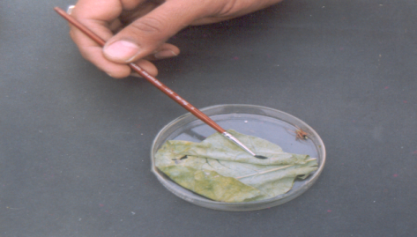
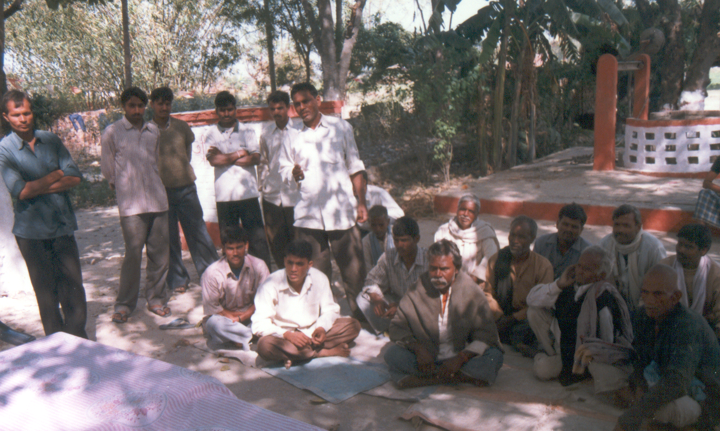
11. Professional Experience

S. No. | Post | Pay Scale | Organization | Nature of work | Total (Years and Months)
1 | Director | AL -15 | Institute of Agriculture Sciences, BHU | Teaching, Research & Extension | 10 Months
2 | Head of Department | AL -15 | Department of Entomology, BHU | Teaching, Research & Extension | 2 Year & 1 Months
3 | Senior Professor | AL -15  Basic pay 224100/- | Department of Entomology, BHU | Teaching, Research & Extension | 5 Year&8 Months
4 | Professor | Basic pay – 2,05,600 | Banaras Hindu University | Teaching, Research & Extension | 14 Years & 10 Months
5 | Associate Professor | 37400-67000 | Banaras Hindu University | Teaching, Research & Extension | 2 Years & 1 Months
6 | Reader | Rs.23451/- Rs.12000-420-18300 | Banaras Hindu University | Teaching, Research & Extension | 5 Years & 10 Months
7 | Lecturer Sr. Scale | 3000-5000 (Pre-revised)  10000-15200  (Revised) | Banaras Hindu University | Teaching, Research & Extension | 3 Years & 11 Months
8 | Lecturer | 2200-4000  (Pre-revised)  8000-13500  (Revised) | Banaras Hindu University | Teaching, Research & Extension | 5 Years

3Teaching :33 Years

4BResearch : 36 years (4 years during doctoral programme

5B and 29 years as a permanent faculty)
(c) Extension : 32 years (actively participating in “Farmers’ Meetings”,
“Farmers Fairs” and conducting interactive Farmers’
Field Schools)
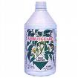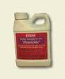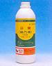

6B12. Research Activities

7BUConcluded

- Bioefficacy and environmental safety of various new insecticide molecules viz., spinosyns, abamectins, chitin synthesis inhibitors and ecofriendly biopesticidal compounds against insect pests
- Integrated pest management modules for vegetables and cereal crops insect pests and diseases were validated and promoted among the villages adopted in four districts of Northeast Indo-Gangetic region of India and promoting need based insecticidal sprays in these IPM villages.
- Insecticide resistance levels were detected in insect pests of national importance against most of commonly used insecticides in the field. The biochemical mechanism of detoxifying enzymes imparting resistance in these insects was studied.
- Impact of chemical pest control measures on non-target organisms, particularly honeybee pollinators was assessed. The role of timing of insecticidal sprayings, volume of insecticidal sprays and different types of sprays on reducing toxicity to these beneficial insects was highlighted.
- Impact of environmental extremities on insect growth and development was analyzed. Various physiological changes that occur during diapause initiation, development and termination were studied and the role of cholinergic system, particularly of acetylcholine and acetylcholinesterase enzyme, during abiotic stress conditions were studied and reviewed.
- Neurotoxicological studies with organophosphorus compounds were conducted and their role in inhibiting the activity of acetylcholinesterase enzyme was further investigated.

8BUOngoing

- Ensuring livelihood security through watershed based farming system modules in disadvantaged districts of Mirzapur and Sonbhadra in Vindhyan region by advocating IPM and ICM strategies
- Insecticide residues studies on various vegetable crops
- Determination of economic injury levels forvegetable insect pests.
- Role of natural enemies (parasitoids & predators) in suppressing insect pest population and their extent of parasitism/predation.
- Impact of integrated farming systemsand climate change on pest infestation.

9BUCurrent Interest
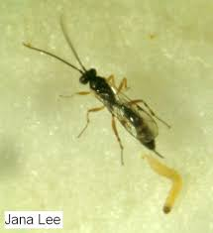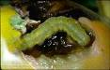
- Integrated insect pest management in agricultural crops
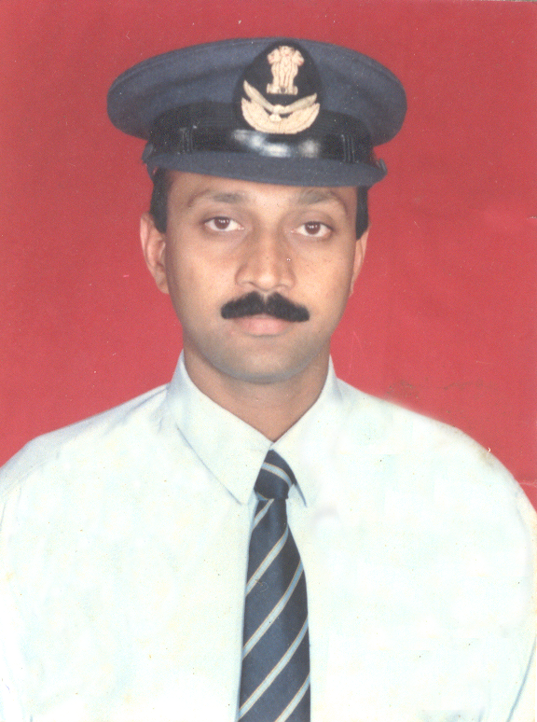
- Biological control of insect pests of horticultural crops
- Molecular mechanism of insecticide resistance
and developing IRM strategies
- Beekeeping
- Impact of climate change on severity of agricultural pest populations

13.Honors and Scholarships
- Won the best Associate NCC Officer award at national level
- Editor, Journal of Aphidology, Aphidological Society of India
- University scholarship during Master’s and Doctoral programme
- Consulting Editor of Contemporary Who’s who of the
American Bibliographical Institute, USA

14. Research activities (guided as a Supervisor)
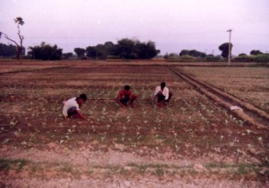
M.Sc. (Ag.) : 46

Ph.D. : 19

    - Uma Shankar (2001) – Identification of some on-farm components for the management prospects of diamondback moth, Plutellaxylostella(L.)

    - Nathu Ram (2001) – Certain management aspects of diamondback moth, PlutellaxylostellaL. on cabbage.

    - Sandeep Kumar (2005) – Insecticide resistance and associated biological fitness in red cotton bug.

    - Ujjwal kr. Bar (2007)–Insecticide residues and their resistance pattern in Plutellaxylostella L. on cabbage and cauliflower.

    - Shailendra Kumar (2007) – Status of infestation, insecticide residue and their resistance pattern in LuecinodesorbonalisGuenee on brinjal

    - Tanweer Alam (2015) – Studies on the population dynamics of diamondback moth (Plutellaxylostella L.) on cauliflower and its management with novel and ecofriendly insecticides

    - Srasvan Kumar G.(2018)–Evaluation of resistance mechanism in certain okra (Abelmoschus esculentus L.) Moench genotypes against sucking pests and fruit borer (EariasvittellaFab.)

    - Deepak Kumar Jaiswal (2019)- Evaluation of neem based biopesticide, chitin synthesis inhibitor, U.V. radiation and chemical insecticide against pulse beetle, Callosobruchus chinensis (L.) In chickpea, Cicer arietinum (L.)

    - Devu Rakshith Roshan (2019). Evaluation of certain plant defence mechanisms in chickpea, (Cicer arietinum L.) varieties against gram pod borer, Helicoverpaarmigera (Hubbner)

    - S. Ramesh Babu (2021). Strategies for management of pulse beetle, Callosobruchus maculatus (Fabricius) for the safer storage of certain pulse commodities.

    - Kamal Ravi Sharma (2021). Screening of certain genotypes/ varieties of rice and validation of different IPM modules against major insect pests.

    - Vinay K. (2023). Studies of gut bacteria on fall armyworm Spodoptera frugiperda (J. A. Smith) and management with noval insecticide molecules on maize.

    - Richa Kumari (2023). Assessment ofresistance risk of thiamethoxam to Mustard aphid LiapahiserysismiKaltanbach (Hemiptera: Aphididae).

*Currently two Ph.D. scholars and fourM.Sc (Ag.) students are enrolled for their theses.As a co-supervisor, contributed to more than 45 M.Sc. (Ag.) &15 Ph.D. theses research.

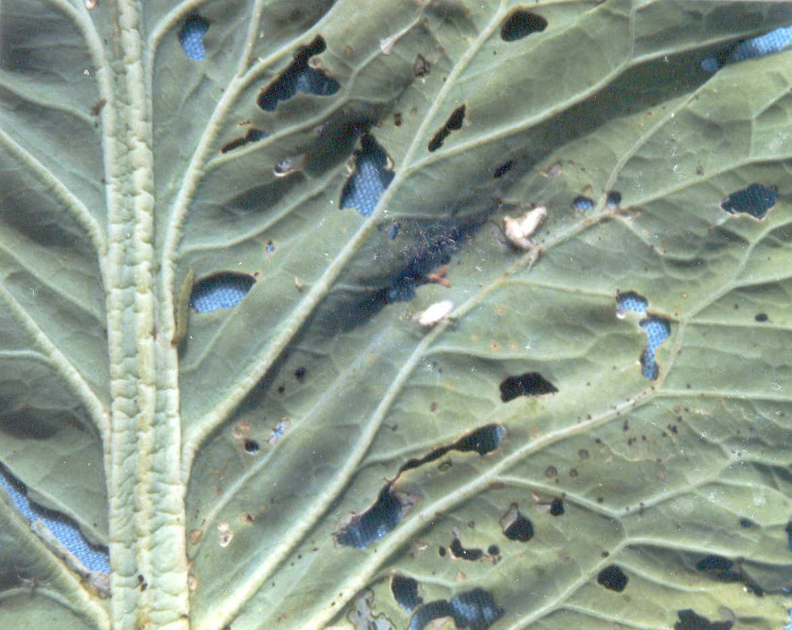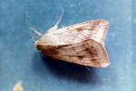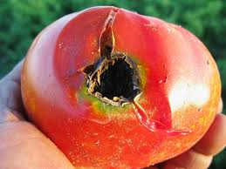

15. Research Projects
CCCompleted

Major Projects:
- Mechanism and Management of insecticide Resistance in diamondback moth, PlutellaxylostellaL. Funded by Indian Council of Agricultural Research, New Delhi.
- National Agricultural Technological project (mission mode) on “Validation and promotion of IPM technology in tomato and cabbage” Funded by ICAR-NATP, New Delhi.
- Ecologically dominated ant species in agroecosystems and their impact on insect species. Funded by Universities Grants Commission, New Delhi.
- Evidences on migration in HelicoverpaarmigeraHubn. as a behavioural strategy in IPM. Funded by UP Council of Science and Technology, Lucknow, U.P.
- Insect pests and diseases of Jatrophacurcas L. and the potential for their management. Funded by Ministry of Agriculture, New Delhi

Minor Projects:Thirty seven minor projects funded by various Organizations / Industry have been completed. The recently completed ones are -
- Monitoring toxicity of Spinosad against diamondback moth, Plutellaxylostella L., from major cole crop growing areas. Funded by Dow Agro Sciences Ltd., Mumbai
- Bioefficacy of Fipronil80 WG against insect pests of rice. Funded by Gharda Chemicals Ltd., Mumbai
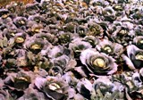

Ongoing
- Academia – Industry collaborative projects on evaluation of bioefficacy of novel insecticide formulations against major insect pests of economically significant crops in Indo-gangetic planes.
U

Submitted
- Experiential learning model instructional apiary – under Model Instructional Farms-An experiential learning, submitted to RKVY, Lucknow,for Rs. 2.50 crore
- Genetic variability in Helicoverpaarmigera Hubner in various agroecological zones of India and its implications in developing regional management modules – submitted to NAIP-ICAR/ ICAR, New Delhi for Rs 56.50 lakhs
- Studies on toxicity of various commonly used plant protection products and development of resistant natural enemies with special reference to Trichogrammabrasiliensis (Ashmad) and Chrysoperlacornea (Stephens) – submitted to UP Council of Agricultural Research, Lucknow, for 56.25 lakhs.
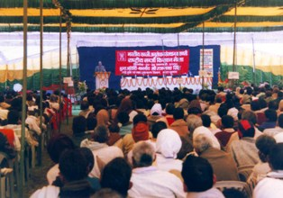
16. Publications

 |  | UPublishedU | UUnderPublicationU
1. | Books | 11 | 03
2. | Book Chapters | 17 | 01
3. | Tech. Bulle. | 03 | -
4. | Manuals | 01 | 01
5. | Research Papers | 122 | 04
6. | Popular article | 09 | 02

10B17. Foreign Visits

- Visited Agro-Ecology Institute, Zhejiang University, Zhejiang, P.R. of China and participated in International Training course on “Biotechnologies for sustainable Agriculture Development”, From 12-26, September, 2000.
- Visited Rothamsted Experimental Station, Harpenden, U.K. to attend and present a research paper in an International Conference on “Resistance 2001- Meeting the challenges”, from 24 – 26 September, 2001.
- Visited various European countries like France, Belgium, the Netherlands and Germanyto visit the labs and interact with scientists of my research field.
- Visited China to participate and present a research paper in XV International Plant Protection Congress at Beijing from 11-16 May, 2004.
- Visited USA to participate and present a research paper in 5th International Symposium on Molecular Insect Science at University of Arizona, Tucson from 20-24 May, 2006.
- Visited Nanyang Technological University, Singapore during “Leadership for Academicians Programme” organized by MHRD, Govt. of India 2019.

11B18. Member of Professional Societies

- Life Member of Indian Society for Advancement of Insect Science, Ludhiana, Punjab, India.


- Life Memberand Fellow of Entomological Society of India,

New Delhi.

- Life Member of Association for Advancement of
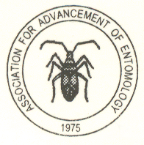
Entomology, Trivandrum, Kerala, India.

- Life Member of Plant Protection Association of India,
NPPTI, Rajendra Nagar, Hyderabad, India.

- Life Member&Fellowof Society of Pesticide Science,
Division of Agrochemicals, IARI-ICAR, New Delhi India,

- Life Memberof Agricultural Technology Development Society, Ghaziabad.
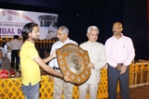

12B19. Administrative Experience/ Extra-curricular

13BActivities (Current& accomplished)

- Flying Officer and Associate NCC Officer
in 7 U.P. Air Sqn. NCC, BHU, Varanasi.
- Vice-President, University Sports Board, B.H.U.
- Administrative Warden & warden of Undergraduate Agriculture hostel, BHU, for seven years
- Chief Admin. Warden, International House Complex, BHU (DDO and Admin. Officer controlling five International Hostels of BHU).
- Chairman, Management Committee of Agro-Cafeteria, Banaras Hindu University.
- Member – Developmental Cell, Institute of Agricultural Sciences, BHU
- Coordinator – Departmental Quality Cell, I.Ag.Sc., BHU
- General Secretary – Institute Alumni Cell &Nodal Person – University Alumni Cell, B.H.U.
- Member, Agriculture Farm Management and Development Committee, Banaras Hindu University
- Chairman – Institute Anti-ragging Committee, I.Ag.Sc., BHU
- Chairman - Athletics at University and Institute Level
- Chairman - Standing CommitteeMember, University Sports Board, Banaras Hindu University.
- Chairman – Institute Disciplinary Committee.
- Prof. Incharge,Agro-Cafeteria, Banaras Hindu University from 16.08.2018 to till date.

14B20. Other Responsibilities

(Current & Accomplished)

- Member Secretary, Departmental Research Committee, Deptt. of Entomology & Agricultural Zoology, Institute of Agricultural Sciences, B.H.U.

- Member- Research Development Council of University, BanarasHinduUniversity.

- Member- Observers team of University Examinations, Banaras Hindu University.

- External Examiner of M.Sc.(Ag.) and Ph.D. theses of other Universities.

- Incharge- Departmental Seminars

- Proctor, Proctorial Board of BanarasHinduUniversity (from March 1999 to April 2000)

16B21. Community Services& Societal Responsibilities
  - Associate NCC Officer – Looking after various Air Wing NCC activities including creating awareness among illiterates, environmental awareness, Swach Bharat mission and health awareness among the people.
  - Helping the farming families to improve their livelihood and economic status while managing various insect pest problems, particularly on vegetables& cereals, through IPM strategies.
  - Transfer of technology through regularly conducting farmers’ meetings (Kisan melas&Kisan goshthis) and rendering scientific and technical services to farmers through Farmers’ Field Schools.
  - Actively involved in NGO Saksham, Kashi Praant and helping the poor and serving the blind, mentally retarded, hearing impaired and PWDs
  - Participating in various community services viz., plantation programmes, blood donation, anti-tobacco rallies, adult literacy, orphanage help etc.

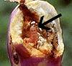


22. Invited Lecture
- Guest lecture during ICAR winter school at IIVR,Varanasi, U.P.
- Invited lecture on “Safe storage of farm produces in integrated farming system at Summer/winter school on Integrated farming system options for Vindhyan region of U.P., I.Ag.Sc., BHU
- Invited lecture in Summer school at ANGR Agricultural University Rajendranagar, Hyderabad, A.P.
- Invited lecture in Workshops on Techniques of herbal drugs standardization at Research & Development Centre, Varanasi, U.P.
- Invited talkin 19th Indian Agricultural Scientist & Farmers Congress at Allahabad, U.P.
- Invited lecture in “National Symposium on Modern Approaches to Insect Pest Management”, Centre of Excellence in Biocontrol of Insect Pest, Department of Zoology, University of Lucknow, U.P.

23. Publications(SCOPUS indexed Journals and UGC Approved NAAS Journals)

1. Books:

- “A text book of Fundamental and Applied Entomology”. Authors:Tanweer Alam, Raju, S.V.S., Ali, M.S. and Raghuraman, M., 2015
Kalyani Publishers, New Delhi
ISBN: 978-93-272-4857-9

- “Applied Zoological Research for Sustainable agriculture & Food Security”. Editors: C. P. Srivastava, R. N. Singh,S.V.S. Raju&M. Raghuraman,2018.
BHU Press, Banaras Hindu University, Varanasi,
ISBN: 81-85305-54-04

- “Recent Trends in Insect Pest Management (Volume – 1)” Editor: S.V.S. Raju and Kamal Ravi Sharma (2019). AkiNik Publications, New Delhi.
ISBN: 978-93-5335-754-2
DOI:https://doi.org/10.22271/ed.book.427 HUURL:https://www.akinik.com/products/427/recent-trends-in-insect-pest-management?UPC=1571646493U

- “Recent Trends in Insect Pest Management (Volume – 2)” Editor: S.V.S. Raju and Kamal Ravi Sharma (2020). AkiNik Publications, New Delhi.
ISBN: 978-93-5335-992-8
DOI:https://doi.org/10.22271/ed.book.547 HUURL:https://www.akinik.com/products/427/recent-trends-in-insect-pest-management?UPC=1571646493U

- “Recent Trends in Insect Pest Management (Volume – 3)” Editor: S.V.S. Raju and Kamal Ravi Sharma (2020). AkiNik Publications, New Delhi.
ISBN: 978-93-90322-51-0
DOI:https://doi.org/10.22271/ed.book.819 HUURL:https://www.akinik.com/products/427/recent-trends-in-insect-pest-management?UPC=1571646493UH

- “Recent Trends in Insect Pest Management (Volume – 4)” Editor: S.V.S. Raju and Kamal Ravi Sharma (2020). AkiNik Publications, New Delhi.
ISBN: 978-93-90420-16-2
DOI:https://doi.org/10.22271/ed.book.978 HUURL:https://www.akinik.com/products/427/recent-trends-in-insect-pest-management?UPC=1571646493UH

- “Recent Trends in Insect Pest Management (Volume – 5)” Editor: S.V.S. Raju and Kamal Ravi Sharma (2021). AkiNik Publications, New Delhi.
ISBN: 978-93-91216-15-3
DOI: https://doi.org/10.22271/ed.book.1234
HUURL:https://www.akinik.com/products/1234/recent-trends-in-insect-pest-management?UPC=1571646493&vol=5U

(viii)“Recent Trends in Insect Pest Management (Volume – 6)” Editor: S.V.S.
Rajuand Kamal Ravi Sharma (2022). AkiNik Publications, New Delhi.
ISBN: 978-93-5570-261-6
DOI: https://doi.org/10.22271/ed.book.1748

(ix) “Recent Trends in Insect Pest Management (Volume – 7)” Editor: S.V.S.
Rajuand Kamal Ravi Sharma (2022). AkiNik Publications, New Delhi.

ISBN: 978-93-5570-217-3

DOI: https://doi.org/10.22271/ed.book.1686

(x) “Recent Trends in Insect Pest Management (Volume – 8)” Editor: S.V.S.
Raju and Kamal Ravi Sharma (2022). AkiNik Publications, New Delhi.

ISBN: 978-93-5570-418-4
DOI: https://doi.org/10.22271/ed.book.1870

(xi) “Recent Trends in Insect Pest Management (Volume – 9)” Editor: S.V.S.
Rajuand Kamal Ravi Sharma (2023). AkiNik Publications, New Delhi.

ISBN: 978-93-5570-614-0

DOI https//doi.org/10.22271/ed.book.2112

Books for Publication:

- “Text Book of Entomology”. Authors: Uma ShankarandRaju, S.V.S.

0BInternational Book Distribution Co., Lucknow

- “Post Harvest Entomology”. Author: SVS Raju

- “Major Insect Pest of Rice Crop and Their Sustainable Pest Management” Authors: Kamal Ravi Sharma, Deepak Kumar Verma and SVS Raju

2. Technical Bulletins:

- Pandey, P.K; Pandey, K.K; Raju, S.V.S and Singh Neeraj. 2002.
Integrated Pest Management in tomato and cabbage(An illustrated bulletin in Hindi), pp. 20.

- Pandey, P.K; Pandey, K.K; Raju, S.V.S and Singh Neeraj. 2004.
Integrated Pest Management in tomato and cabbage – A successful story (In Hindi), pp. 8.

- Srivastava, C.P., Raju, S.V.S. and Ramesh Chandra. 2004
Mass production of Helicoverpaarmigera NPV virus (In Hindi), pp. 4

- Manuals :

- Uma Shankar, Raju, S.V.S. and Singh, D.P. 2005
Manual of Pest Management (in reference to biological control and non-insect pests)
Kushal Publications and Distributors, Varanasi, India, pp52

- Uma Shankar and Raju, S.V.S., 2011
Introductory Entomology – A Technical cum Practical Manual
(Under Publication)

- Book Chapters:

- Raju, S.V.S., Singh, H.K. and Singh, H.N. 2006. Time and population forecasting for Indian Gypsy moth, Lymantria obfuscate Walk. In Kashmir valley. In Horticulture for sustainable income & Environmental Protection. Vol. 1, ‘Advances in Horticultural Practices: Fruits & Ornamentals. Ed. B.B. Singh, K. Akali Sema and Pauline Alila, Concept Publishing Co., New Delhi, pp. 296-307.

- Raju, S.V.S. 2010. Integrated Pest Management : A suitable approach for better agricultural practices. In Modern Approaches to Insect Pest Management. Eds. Omkar, Geetanjali Mishra and Kalpana Singh, Anuj Printers, Lucknow, pp. 25 – 35

- Uma Shankar and Raju, S.V.S., 2012. Integrated Pest Management in Vegetable Ecosystem. In “Ecologically Based Integrated Pest Management”, eds. D.P. Abrol and Uma Shankar, New India Publishing Agency, New Delhi, pp 619-650

- Raju, S.V.S. and Uma Shankar, 2012. Role of Bacillus thuringiensis in Agriculture – An Overview

- In “Recent Approaches in Entomology for Sustainable Pest Management”
Under Publication

- Deepak Kumar Jaiswal, S.V.S Raju, Devu Rakshith Roshan, Kamal Ravi Sharma and Prateek Singh, 2018. Contemporary approaches for genetic engineering in insectResistance transgenic plants. ADVANCES IN BIODIVERSITY CONSERVATION FOR SUSTAINABLE DEVELOPMENT. Ed. Joginder Singh, Rashmi Nigam and Wajid Hasan, Parmar Publisher and Distributors, Jharkhand, India, pp. 238-241.

- Deepak Kumar Jaiswal, S.V.S Raju, Saxena R.P.N. and Prateek Singh 2016.
Role of Insect Vectors in Transmitting Viral Diseases of Plants. Role of BASIC SCIENCES in TRANSLATIONAL RESEARCH in Ayurvedic Medicine.
Mahima Research Foundation and Social Welfare 194, Karaundi, Banaras Hindu University, Varanasi-221 005, UP, India

- Devu Rakshith Roshan,S.V.S Raju and Deepak Kumar Jaiswal 2017.
Role of Nanotechnology in Insect Pest Management, LATEST TRENDS IN ZOOLOGY AND ENTOMOLOGY SCIENCES Volume – 4. AkiNik Publications, New Delhi.pp. 51-64.

- Deepak Kumar Jaiswal, S.V.S Raju, Devu Rakshith Roshan, Kamal Ravi Sharma, Manish Kumar Singh and Vaibhav Singh, 2018.
Genetic Engineering.Sustaible Agriculture for Food Security. Ed. Ashok Kumar Yadav, Triyugi Nath, R.S. Mishra, Manoj Kumar Singh and Manju Tiwari, Bharti Publication, New Delhi, India, pp. 106- 110.

- Devu Rakshith Roshan,S.V.S Raju, Deepak Kumar Jaisawal,Ramesh Babu Sabbavarapu and Kamal Ravi Sharma, 2018.
Role of plant and animal based insecticides to mitigate insecticide pollution in India. SustaibleTechnologyies for Better Environment. Ed. Ashok Kumar Yadav, R.S. Mishra, Manju Tiwari, Vivek Mishra and R.R. Mishra, Bharti, New Delhi, India, pp. 193- 209.

- S.V.S. Raju and Devu Rakshith Roshan, 2018.
Insect Pest Management in Organic Farm Production. Applied Zoological Research For Sustainable Agriculture and food Security. Odisha

12. Kamal Ravi SharmaSVS Raju, Saxena RPN, R. Singh and Prateek Singh, 2019.
Usage of Biopesticides for Insect Pest Management and Their StatusinIndia. Latest Trends in Zoology and Entomology Sciences (vol- 7).Ed. Subha Ganguly, AkiNik Publications New Delhi. pp 75-89.

13. S. Ramesh Babu, S.V.S. Raju, Kamal Ravi Sharma and Dhanapal R, 2019. Biotechnological Tools and Genetic Enhancement ofBio-Control Agents for Sustainable Pest Management. Recent Trends in Insect Pest Management (Vol- 1).Ed. SVS Raju and Kamal Ravi Sharma.AkiNik Publications New Delhi. pp 17-29.

14. Kamal Ravi Sharma, SVS Raju, S. Ramesh Babu and Rashmirekha Singh (2020).Implementation of Integrated Pest Management Approaches in Stored Grain. Climate Change and its Impact on Global Food Security and Sustainability of Agriculture, Ed. R. K. Rao, P.K. Sharma, M. Raghuraman and R. S. Meena, Mahima Research Foundation and Social Welfare, Varanasi, India, pp. 90-97.

5. Research papers (both National & International)

- Singh H.K., Singh H.N. and Raju S.V.S. (1991)
Acetylcholinesterase activity and the effect of substrate concentrations in various developmental stages of Dysdercuskoenigii(F).
J. Scientific Res. 41A: 211–217.

- Raju S.V.S., Jaiswal P.K. and Singh H.N. (1993)
Effect of temperature on bioenergetic changes in Indian gypsy moth Lymantria obfuscataWalk (Lepidoptera: Lymantridae)
J. Appl. Biol. 3: 33-35.

- Raju S.V.S., Kumar G.T. and Singh H.N. (1994)
Effect of temperature on egg diapause termination of Indian gypsy moth, Lymantria obfuscataWalk and survival of its egg parasite, AnastatuskashmiriensisMathur.
Naturalia, 19: 109-117.

- Raju, S.V.S. and Singh H.N. (1994)
Changes in egg weight and diapause development in Indian gypsy moth, Lymantria obfuscataWalk at certain temperature conditions.
Bioved, 5(1): 11-14.

- Raju, S.V.S., Chaudhary M.K. and Singh H.N. (1994)
Bioefficacy of some commonly used insecticides against Plutellaxylostella L.
Indian J. Entomol., 56(3): 246-250.

- Raju S.V.S., (1995)
Effect of monocrotophos and phosphamidon on Indian gypsy moth egg parasite, AnastatuskashmiriensisMathur.
Pestology,XIX(2): 14-19.

- Raju, S.V.S. and Singh H.N. (1995)
Role of temperature in egg diapause termination and survival of Lymantria obfuscataWalk (Lepidoptera : Lymantridae)
Pestology, XIX(6): 33-37.

- Raju, S.V.S. and Dhaliwal H.S. (1995)
Impact of chemical pest control measures on Apis mellifera L. population foraging on Brassica seed crop : Effect of time of spray.
J. Rec. Adv. Appl. Sci., 10(1&2): 31-38.

- Raju, S.V.S. and Dhaliwal H.S. (1995)
Impact of chemical pest control measures on Apis mellifera L. population foraging on brassica seed crop: Effect of spray volume.
J. Rec. Adv. Appl. Sci., 10(1&2): 41-48.

- Raju, S.V.S. and Singh, H.N. (1995)
Resistance levels in the field population of Plutellaxylostella (L.) to certain commonly used insecticides.
Indian J. Entomol., 57(2): 164-166.

- Raju, S.V.S., Sastry, V.M.V.S. and Rao G.R. (1996)
Feeding deterrency and toxicity of certain pteridophyte plant extracts against HeliothisarmigeraHubn. and Spodoptera lituraF.
Shashpa, III(i): 47-50.

- Raju, S.V.S. (1996)
An overview of insecticide resistance in PlutellaxylostellaL.
Resistant Pest Management, 8(1): 23-24.

- Singh, N.N., Maurya R.K. and Raju, S.V.S. (1998)
Relative toxicity of some commonly used insecticides against armyworm, Mythimnaseperata(Walker). J. Insect. Sci. 11(1): 82-83.

- Raju, S.V.S. and Kumar, A. (1998).
Incidence and management of PlutellaxylostellaL. with Bacillus thuringiensis Berliner and some other insecticides.J. Sust. Pest. Manage.,1: 81-85.

- Nathu Ram, Raju, S.V.S. and Singh, H.N. (2000)
Varietal resistance of different cabbage varieties/entries against Plutellaxylostella L. under field conditions.
Indian J. Entomol., 62(2): 175-180.

- Nathu Ram, Raju, S.V.S. and Singh, H.N. (2001)
Bioefficacy of some conventional and ecofriendly insecticides against diamondback moth, Plutellaxylostella L. on cabbage.
Indian J. Entomol., 63(4): 429-434.

- Uma Shankar and Raju, S.V.S. (2002)
Bio-efficacy of some new insecticidal molecules against diamondback moth, Plutellaxylostella (L.) on cauliflower. Pestology, XXVI(8): 41-46.

- Nathu Ram and Raju, S.V.S. (2002)
Varietal resistance of different early cauliflower varieties against diamondback moth, Plutellaxylostella, under natural infestation.Indian J. Entomol., 64(1): 21-26.

- Uma Shankar and Raju, S.V.S. (2002)
Comparative economics of some ecofriendly and conventional insecticidal treatments against Plutellaxylostella (L.) on cauliflower.
Pestology, XXVI(10): 15-19

- Singh, M.K., Raju, S.V.S. and Singh, H.N. (2002)
Larval age effects susceptibility to Bacillus thuringiensis in diamondback moth, Plutellaxylostella L.
Indian J. Entomol., 64(4): 475 – 483

- Pandey, R and Raju, S.V.S. (2003)
Log dose Probit studies of different eco-friendly insecticides against Plutellaxylostella(L.)
Indian J. Entomol., 65(1): 141-143

- Singh, M.K., Raju, S.V.S. and Singh, H.N. (2003)
Laboratory bioassay of Bacillus thuringiensis formulation against diamondback moth, Plutellaxylostella L.
Indian J. Entomol., 65(4): 86-93

- Pandey, R. and Raju, S.V.S. (2003)
Bioefficacy of some eco-friendly insecticides against diamondback moth (Plutellaxylostella L.)
Indian J. Entomol. 65(3): 368 – 372

- Bar, U.K., Uma Shankar and Raju, S.V.S. (2004)
Seasonal abundance of the larval parasitoid Cotesia plutelleaKurdjumov and its extend of natural parasitization of diamondback moth larvae
Annals of plant Protection Sciences, 12(1): 214 –216

- Bar, U.K., Uma Shankar and S.V.S. Raju (2004)
Seasonal abundance and parasitization of diamondback moth and larval parasitoid, Cotesia plutellae.
Annl. Pl.Protec.Sci., 12(1): 193-202

- Uma Shankar,Ujjwal Kumar Bar and Raju, S.V.S. (2005)
Impact of inter cropping with cauliflower on diamondback moth, Plutellaxylostella L.
Indian Journal of Plant Protection, 33(1): 43-47

- Uma Shankar, Bar, U.K. and Raju, S.V.S. (2005)
Locational specific performance of Cotesia plutelleaKurdjumov in parasitization of Plutellaxylostella L. larvae.
Shaspa, 12(2): 89-92

- Das, R.K., Bar, U.K., Kumar, S. And Raju, S.V.S. (2006)
Bioeffectivity of some botanicals and conventional insecticides against Plutellaxylostella (L.) from IPM fields.
Resistant Pest Management, 15(2): 15- 18

- S.V.S. Raju, U.K. Bar and U Shankar (2006)
Resistance levels and mechanism of resistance in Plutellaxylostella L. to certain commonly used insecticides.
J. Insect Sci., 6: 49-50

- Raju, S.V.S. , Bar, U.K., Uma Shankar and Shailendra Kumar (2007)
Scenario of infestation and management of eggplant shoot and fruit borer, Leucinodesorbonalis Guen., in India
Resistant Pest Management, 16(2): 14 – 16

- Agarwal, V.M., Rastogi, N and Raju, S.V.S. (2007)
Impact of predatory ants on two lepidopteran insect pests in Indian cauliflower agroecosystems.
J. Appl. Entomol., 131(7): 493 – 500

- Uma Shankar, S.V.S. Raju, Md. Monobrullah and Sanjeev Rai (2007)
Efficacy of intercropping as a management strategy for the control of Plutellaxylostella (L.) on cabbage.
Veg. Sci., 34 (2): 208-210

Raju, S.V.S., Shailendra Kumar and Uma Shankar (2008)

Population dynamics and development of field resistance to insecticides in red cotton bug (dysdercuskoenigii f.)

International J. Tropical Agriculture, 26 (1-2), 103 - 107

Raju, S.V.S., Shailendra Kumar and Uma Shankar (2008)

Comparative biological and morphological parameters associated with red cotton bug on okra crop from low and high insecticide input areas.
International J. Tropical Agriculture, 26 (1-2), 109 – 113

- Raju, S.V.S., Sandeep Kumar and Uma Shankar (2009)
Development of resistance in laboratory selected Dysdercuskoenigii (F.) to certain commonly used insecticides.
Veg. Sci., 36(3), 408-411

- Singh, K., Singh, D.K. and Raju, S.V.S. (2009)
Bio-efficacy of certain neem based formulations against white fly, Bemisiatabaci Gennadius causing leaf curl disease in tomato.
Indian Journal of Entomology. 71 (2): 165-167

- Patel, J., Raju, S.V.S., Sarma, B.K. and Singh, R (2010)
Screening and biochemical characterization of certain Pseudomonasfluorescens isolates against Helicoverpaarmigera (Hubner)
Journal of Developmental Microbiology and Molecular Biology, 1:45-54
- Kuldeep Singh and Raju, S.V.S. (2011)
Bioefficacy of neem based formulations against tomato fruit borer (Helicoverpaarmigera Hubner)
Indian J. of Entomol., 73(2) : 186-189

- Kuldeep Singh, D.K. Singh and Raju,S.V.S. (2011)
Evaluation of tomato germplasms/cultivars for comparative level of resistance against tomato fruit borer (Helicoverpaarmigera Hubner)
Pestology, XXXV (11) : 17 – 20

- Kuldeep Singh, D.K. Singh and Raju,S.V.S. (2011)
Population succession of tomato fruit borer (Helicoverpaarmigera Hubner) on tomato (Lycopersiconesculentum Mill.) agro-ecosystem in eastern region of U.P.
Vegetable Science, 38 (2) : 152 – 155

- Kuldeep Singh, Raju,S.V.S. andD.K. Singh (2011)
Seasonal incidence of whitefly (Bemisiatabacigennadius) on tomato (Lycopersiconesculentum Mill.) in eastern region of U.P.
Vegetable Science, 38 (2) : 200 – 202

- Manju Vani, V., Singh, A.K., Raju, S.V.S., Singh, B.K. and Singh, B. (2012)
Genotype clustering in okra, Abelmoschusesculentus (L). Moench
Environment & Ecology,30(3C): 1197 – 1202

- Manju Vani, V., Singh, A.K., Raju, S.V.S., Singh, B.K. and Singh, S.P. (2012)
Variability studies in okra, Abelmoschusesculentus (L). Moench
Environment & Ecology,30(3C): 1203 – 1206

- Singh, K., Singh, N.N. and Raju, S.V.S. (2012)
Studies on preying potential of lady Bird Beetle (Coccinella septempunctata Linn.) In relation to mustard aphid (Lipaphiserysimi Kaltenbach).
Indian Journal of Entomology.74 (1): 93-95.

- Singh, K., Singh, N.N. and Raju, SVS (2012).
Feeding potential of grubs/larvae of syrphids and coccinellid predators on mustard aphid, Lipaphiserysimi (Kalt.).
Indian Journal of Plant Protection, 40(2):157-159.

- Omprakash, S., Raju, S.V.S. and Sunil Kumar, M. (2013)
Seasonal incidence and efficacy of certain low risk insecticides against Amrascadevastance Distant on brinjal.
International J. of Plant Protection, 6(2): 253-256

- Omprakash, Sand Raju, S.V.S. (2013)
Bioefficacy of some insecticides against Bemisiatabaci (Genn.) on brinjal.
Indian J. Entomol., 75(4): 310-314

- Meena, L.K. and Raju, S.V.S. (2014)
Bioefficacy of insecticides against whitefly and leafhopper of tomato under field conditions.
Ann. Pl. Protec. Sci., 22(1): 14-17

- Chauhan, S.K., Raju, S.V.S., Meena, B.M., Nagar, R, Kirar, V.S. and Meena, C. 2014. Bioefficacy of newer molecular insecticides against diamondback moth (Plutellaxylostella L.) on cauliflower.
Agriculture for Sustainable Development, 2(1):22-26

- Meena, L.K. and Raju, S.V.S. (2014).
Bioefficacy of newer insecticides against tomato fruit borer, Helicoverpaarmigera (Hubner) on tomato, Lycopersicon esculentum. Mill under field conditions
The Bioscan, 9(1): 347-350

- Meena, L.K. and Raju, S.V.S. 2015.
Efficacy of insecticides against fruit borer, Helicoverpaarmigera (Hubner) on tomato.
Indian J. Entomol., 77(2):201-202

- Omprakash,S. and Raju, S.V.S. 2014.
Incidence of Henosepilachnavigintioctopunctata Fab. on brinjal in eastern Uttar Pradesh.. InternationalJournal of Applied Biology and Pharmaceutical Technology, 5(1): 181-18

- Singh, K., Raju, S.V.S. and Singh, N.N. 2015.
Impact of different intercroppings in the management of pod borer, Helicoverpaarmigera Hub. in chickpea.
J. Entmol. Res., 39(3): 189-192

- Roshan, D. R., Raju, S. V. S and Sharma, S. (2015).
Seasonal abundance and evaluation of new insecticides against rice leaf folder.Cnaphalocrocismedinalis(Guenee).
Eco. Env. & Cons. 21 (December Suppl., ):S81-S85.

- Roshan, D. R., Raju, S. V. S. and Singh, K. N. 2016.
Effect of environmental factors on population dynamics of Scripophagaincertulas(Walker) and its management with novel insecticides in rice ecosystem.
J. Exp. Zool. India.19(1): 327-332.

- Alam, T, Raju, S.V.S., Raghuraman, M and Kumar, R.K. 2016.
Population dynamics of diamondback moth, Plutellaxylostella(L.) on cauliflower Brassica oleracea l. var. botrytis in relation to weather factors of eastern Uttar Pradesh region.
J. Exp. Zool. India,19(1): 286-290.

- Roshan, D. R., Raju, S. V. S. and Singh, K. N. 2016.
Relative Efficacy of Acetamiprid + Fipronil Combination Formulation against BPH (NilaparvatalugensStal) & GLH (NephotettixvirscensDistant) in Rice.
Journal of Pure and Applied Microbiology. Vol. 10(4): 2773-2782.

- Singh, N.N., Mishra, V.K. and Raju, S.V.S. 2017.
Regulation of insect diapause, A review.
J. Exp. Zool. India. 20 (1): 1-14.

- Kumar, K. R., Singh, N. N. and Raju, S. V. S. 2017.
Comparative efficacy of certain newer insecticidesagainst shoot and fruit borer,LeucinodesorbonalisGuenee in brinjal.
J. Exp. Zool. India.20( 1): 137-142.

- Kumar, K. R., Singh, N. N., Raju, S. V. S. and Mishra, V.K. 2017.

Influence of Abiotic Factors on Seasonal Incidence of Brinjal shoot and fruit Borer, LeucinodesorbonalisGuen. in Varanasi Region

Int.J.Curr.Microbiol.App.Sci.6(4): 1513-1518.

Roshan, D. R. and Raju, S. V. S. 2017.

Influence of abiotic and biotic factors on population dynamics ofBPH (NilaparvatalugensStal) and GLH (Nephotettixvirescens Distant).

Crop Res.52 (1, 2 & 3): 67-73

Kumar, G. S., Raju, S. V. S., 2017.
Effect of Different Group of Insecticides Against JassidAmarascabiguttullabeguttulla (Ishida) on Okra (Abelmoschus esculentus L.)

Trends in Biosciences, 10(35): 7347-7351.

Kumar, G. S., Raju, S. V. S., 2017.
Impact of Different Group of insecticides Against Aphids Aphis gossypii (Glover) on Okra (Abelmoschus esculentus L.)

Trends in Biosciences, 10(35): 7364-7369.

- Kumar, G. S., Raju, S. V. S. and Kattula, S. Y. 2017.
Impact of abiotic factors on the population fluctuations of sucking insect pests on okra (Abelmoschus esculentus L.)
Journal of Entomology and Zoology studies.5(3): 1258-1263.

Roshan, D. R. and Raju, S. V. S. 2017.
Seasonal Abundance of Leptocorisa acuta (Thunberg) and its Management with Novel Insecticides
Trends in Biosciences,10(19): 3439-3442

- Kumar, G. S. and Raju, S. V. S. 2017.
Screening of Certain Okra Genotypes against Yellow Vein Mosaic Virus Disease under Field Conditions.
Int.J.Curr.Microbiol.App.Sci. 6(6):1461-1466.

- Kumar, K. R., Singh, N. N., Raju, S. V. S., Prakask, P.andMishra, V.K. 2017.
Shoot and fruit borer,Leucinodesorbonalisincidence as influenced by total chlorophyll content in different brinjal varieties.
Journal of Entomology and Zoology Studies.5(5): 360-363.

- Kumar, K. R., Singh, N. N., Raju, S. V. S., Prakask, P.andMishra, V.K. 2017.
Biochemical bases of shoot and fruit borer resistance LeucinodesorbonalisGuenee in different brinjal varieties and their correlation with shoot and fruit infestation.
Journal of Insect Science, 30(2): 210-125.

- Kumar, G. S., Raju, S. V. S. and Kattula, S. Y. 2017.
Role of Different Abiotic Factors Influencing Fluctuations of Fruit and Shoot Infestation Caused by Eariasvittellaon Okra (Abelmoschus esculentus L.)
Int.J.Curr.Microbiol.App.Sci,. 6(6):2514-2521

- Kumar Srasvan G.,Raju. S.V.S. Roshan D. Rakshith. Jaiswal Deepak Kumar and Singh Prateek Kumar.2017.
Biology and morphometry of Eariasvittela (Fsabricus) (Lepidoptera – Noctuidae) on okra under laboratory condition.
Journal of experimental zoology India,20 (2): 1049-1052

- Valluru Manju Vani, B.K. Singh and Raju, S.V.S. 2017. GCA and SCA for fruit parameters of okra (Abelmoschus esculentus L. Moench).
Int. J. Curr. Microbiol. App. Sci. 6(6): 1576-1582.

- Sharma, K. R.,Raju S.V.S., Roshan D.Rakshith and Jaiswal Deepak Kumar.2018.
Efeect of abiotic factors on yellow stem borer, Scirophagaincertulus(Walker) and rice leaf folder, Cnaphalocrocismedinalis (Guenee) population.
Journal of experimental zoology India, 21 (1): 233-236

- Sharma, K. R., Raju, S.V.S., Deepak Kumar Jaiswal and Prateek Singh, 2018.
Efficacy of certain newer insecticide formulations against yellow stem borer, Scirpophagaincertulas (walker) infesting on rice crop.
Journal of experimental zoology India, 21 (2): 771-775.

- Sharma, K. R. and Raju, S.V.S., 2018
Efficacy of new insecticide combinations and alone applicationagainst leaffolder, Cnaphalocrocismedinalis(Guenee) Rice crop
Annals of Plant Protection Sciences,26 (2): 236-239.

- Sharma, Sourab, Raju, S.V.S. and D. Rakshith Roshan, 2018
Efficacy of certain insecticides against diamond back moth on cauliflower
Indian Journal of Entomology, 80(3): 1163-1165.

- Sharma, K. R.,Raju,S.V.S. and Deepak Kumar Jaiswal, 2018.
Influence of environmental effect on the population dynamics of brownplant hopper, Nilaparvatalugens(Stal) and white-backed plant hopper,Sogatellafurcifera(Hovarth) in Varanasi region.
Journal of Entomological Research, 42 (3): 339-342.

- Jaiswal, D. K., Raju, S.V.S.,Kumar, Dinesh and Vani,V. Manju, 2018.
Studies on biology of pulse beetle, Callosobruchus chinensis (L.) on stored chickpea under laboratory conditions.
Journal of Pharmacognosy and Phytochemistry, 7(6): 464-467

- Roshan, D. R. and Raju, S.V.S.,2018.
Effect of certain weather parameters on population fluctuation of gram pod borer (HelicoverpaarmigeraHubner) in chickpea.
Journal of Pharmacognosy and Phytochemistry, 7(6): 1093-1096

- Roshan, D. R. and Raju, S.V.S.,2018.
Influence of Morphological Characters of Chickpea Varieties on Damage by Gram Pod Borer (HelicoverpaarmigeraHubner).
Int.J.Curr.Microbiol.App.Sci (2018) 7(12): 2025-2033.

- Jaiswal, D. K., Raju, S.V.S., Ingle Deepak Shyamrao, Prateek Singh and G Srasvan Kumar, 2019.
Effect of some seed protectants on adult emergence of pulse beetle, Callosobruchus chinensis (L.) in fresh chickpea seeds under storage conditions.
Journal of Pharmacognosy and Phytochemistry, 8(2): 534-537.

- Deepak Kumar Jaiswal, S.V.S Raju, G. Srasvan Kumar, Kamal Ravi Sharma, Dhirendra Kumar Singh and Prudhvi Raj Vennela (2018).
Biotechnology in plant resistance to insects.
Indian Journal of Agriculture and Allied Sciences, 4 (1): 7-18.

- Kamal Ravi Sharma,S.V.S. Raju, Deepak Kumar Jaiswal and Sudeshna Thakur (2018).
Biopesticides: an effective tool for insect pest Management and current scenario in india.
Indian Journal of Agriculture and Allied Sciences, 4 (2): 59-62.

- Jaiswal, D. K., Raju, S.V.S., Dhirendra Kumar Singh and Vaibhav Singh, 2019.
Evaluation of some seed protectants against pulse beetle, Callosobruchus chinensis (L.) in stored chickpea seeds under laboratory conditions.
The Pharma Innovation Journal, 8(3): 188-192.

- KR Sharmaand SVS Raju,(2019).
Field Efficacy of Certain Combination Insecticide Formulation against Paddy Plant hoppers.
Pesticide Research Journal. 31(1): 119-125.

- Deepak Kumar, Kamal Ravi Sharma and S.V.S. Raju (2019).
Influence of environmental factors on the population dynamics of chilli thrips, Scirtothrips dorsalis (Hood) and aphid, Aphis gossypii (Glover).
Journal of Experimental Biology and Agricultural Sciences, 7(3): 289 – 294.

- Deepak Kumar, SVS Raju and Kamal Ravi Sharma (2019).
Population Dynamics of Chilli Mite and their Management with Certain Newer Insecticide Combination Formulations.
Journal of Pharmacognosy and Phytochemistry, 8(2): 403-407

- Deepak Kumar Jaiswal, S.V.S. Raju, V. M. Vani and Kamal Ravi Sharma(2019).
Studies on life history and host preference of pulse beetle, Callosobruchus chinensis (L.) on different pulses.
Journal of Entomological Research, 43 (2): 159-164.

- Deepak Kumar,Kamal Ravi Sharmaand S.V.S. Raju (2019).
Field Efficacy of Certain Newer Insecticide Formulations Against Chilli Thrips, Scirtothrips dorsalis (Hood), and Chilli Aphid, Aphis gossypii (Glover).
Annals Plant Protection Sciences, 27(3): 324-328.

89. Kamal Ravi Sharma, SVS Raju, KN Singh and D Rakshith Roshan (2019).Effects of Environmental Factors on Population Dynamicsof Rice Earhead Bug and Their Management with NewerInsecticide Combinations and Sole Insecticide.
Bangladesh J. Bot. 48(4): 973-979

90. Kalpana Bisht, N.N. Singh andSVS Raju (2019).Certain Morphological characters imparting resistance in tomato against fruit borer, Helicoverpaarmigera (Hubner). Bulletin of Environment, Pharmacology and Life Sciences, 8 (1): 70-73.

91. Kalpana Bisht, N.N. Singh andSVS Raju (2018).Evaluation of comparative resistance in tomato varieties/germplasmsagainst fruit borer, Helicoverpaarmigera (Hubner).
Journal of Entomology and Zoology Studies.7(5): 581-588.
.
92. S. Ramesh Babu, SVS Raju,P.S.Singh and Kamal Ravi Sharma (2020).Determination of toxicity of newer insecticide molecules against pulse beetle, Callosobruchus maculatus (Fabricius) (chrysomelidae: coleoptera) under laboratory conditions.
Journal of Experimental Biology and Agricultural Sciences,8(1):35-40.

93.N Vinay, SVS Raju, S Ramesh Babu And Kamal Ravi Sharma (2020). A review on management of major insect pests in castor.
Journal of Oilseeds Research, 37 (Special Issue): 194-195.

94. Kumari, R., Singh, N. N., Raju, S. V. S., & Singh, P. S. (2020). Effect of different temperatures on Trichogrammachilonis (Hymenoptera: Trichogrammatidae) parasitizing the eggs of Corcyra cephalonica and Helicoverpaarmigera.
Journal of Entomology and Zoology Studies 2020; 8(2): 419-423.

95. S. Ramesh Babu, S.V.S. Raju, R. Dhanapal, Kamal Ravi Sharma (2020). Storage of chickpea grains (Cicer arietinum L.) in triple layer bags prevent losses caused by Callosobruchus maculatus (F.) (Coleoptera: Chrysomelidae) under laboratory conditions.
Journal of Stored Products Research 88: 101685

96. Bhawani Singh Meena, S.V.S. Raju, S. Ramesh Babu and Kamal Ravi Sharma (2020).Effect of Environmental Factors on the Population Dynamics of Major Sucking Pests of Okra (Abelmoschus esculentus L.).
Journal of Entomological Research.44 (1): 77-82

97. Deepak Kumar,Kamal Ravi Sharma, S.V.S. Raju and S Ramesh Babu (2020). Effects of Environmental Factors on the Population Dynamics of Chilli Fruit Borer and Their Management with Newer Insecticides Combination and Sole Insecticides. International Journal of Agricultural & Statistical Sciences. 16(1):395-400

98. Pankaj Kumar Mohanta, SVS Raju and GS Giri (2020). Bio-efficacy of certain insecticidal molecules against sucking pests of rice.
Journal of Pharmacognosy and Phytochemistry,9(1): 2107-2113.

99. Vani, Valluru Manju, B. K. Singh, and Raju, SVS and Anand Kr Singh (2020).
GCA and SCA for plant and pod parameters of Okra [Abelmoschus esculentus (L.) Moench].
Journal of Pharmacognosy and Phytochemistry, SP6: 332-338

100. Raju, S.V.S., Sharma, K.R., Ramesh Babu S and Mohanta, P.K. (2021). Population dynamics of insect pests in rice ecosystem.
Indian Journal of Entomology, 83(1): 39-42.

101.Vani, Valluru Manju, B. K. Singh, and Raju, SVS and Anand Kr Singh(2021). Studies on genetic variability, heritability and genetic advance for various quantitative traits in okra [Abelmoschus esculentus (L.) Monech] genotypes under north gangetic plains of Uttar Pradesh.
Journal of Pharmacognosy and Phytochemistry, 10(3), 272-274.

102. S. Ramesh Babu, S.V.S. Raju, P.S. Singh, Kamal Ravi Sharma (2021). Host Preference and Damage Assessment of Pulse Beetle, Callosobruchus maculatus (Fabricius) (Chrysomelidae: Coleoptera) on Different Hosts.
Legume Research.2021, (44):1482-1487.

103.Kamal Ravi Sharma, S.V.S. Raju, R.S. Meena, S Ramesh Babu, and Saurav Singla (2021).Weather based prediction model for green leafhopper (GLH), Nephotettix virescens Distant of rice in middle gangetic plains. Journal of Entomological Research, 45 (4): 675-678.

104. Kuldeep Singh, S.V.S. Raju and Kamal Ravi Sharma (2022). Field effcacy of novel insecticides emamectin benzoate and spinosad against fruit borer, Helicoverpaarmigera (Hübner) on tomato. Journal of Entomological Research, 46 (1) : 106-110.

105.Kamal Ravi Sharma, S.V.S. Raju, Kuldeep Singh, S Ramesh Babu, Vinay N., Basant Kumar Dadrwaland Mohit Yadav (2020).
Impact of synthetic pesticide on agro-ecosystem in India: A comprehensive review.
Indian Journal of Agricultureand Allied Sciences, 6 (4): 27-34.

106. G. S. Giri, SVS Raju, SD Mohapatra and Munmun Mohapatra (2022).
Effect of elevated carbon dioxide on biology and morphometrics parameters of yellow stem borer, Scirpophagaincertulasinfesting rice (Oryza sativa).
Journal of Agrometeorology, 24 (1): 77-82.

107.Sharma, K. R., Raju, S. V. S., Singh, K., & Babu, S. R. (2022).
Effect of Crop Growth Stages on the Field Population of Rice Hoppers.
Indian Journal of Entomology, 1-3.

108. Kumar, R. S., Nath, P., Raju, S. V. S., & Nagabhushanam, U. (2022).
Evaluation of efficacy of ecofriendly biopesticides against gram pod borer and legume pod borer of short duration pigeonpea.
The Pharma Innovation Journal 2022; SP-11(10): 1646-1652

109. Vinay, N., Raju, S. V. S., Srinivasa, N., & Sharma, K. R. (2022).
Incidence of fall armyworm, Spodoptera frugiperda (JE Smith)(Lepidoptera: Noctuidae) on finger millet and sorghum in Karnataka, India.
Journal of Entomological Research, 46(3), 636-641.

110. Vinay, N., Raju, S. V. S., Babu, S. R., & Sharma, K. R. (2022).
First report on occurrence of fall armyworm, Spodoptera frugiperda (JE Smith)(Lepidoptera: Noctuidae) from North Eastern plain zone of Uttar Pradesh, India.
J. Exp. Zool. India, 25: 1598-604.

111.Chaitanya, G., Singh, P. S., Raju, S. V. S.,& Babu, R (2022).
Screening of certain black gram varieties against pulse beetle (Callosobruchus maculatus) under free choice method.
J. Exp. Zool. India 25(2): 1617-1620.

112.Arya, V., Narayana, S., Tyagi, S., Raju, S. V. S., Srivastava, C. P., Sinha, T., & Divekar, P. (2022).
DNA barcoding of fruit flies associated with cucurbit ecosystem and combination of Cue-Lure and Methyl Eugenol in trap is not effective for mass trapping of responsive fruit flies.
Phytoparasitica, 50(3), 683-695.

113.Raju, S. V. S., Pramanik, K., Vinay, N., & Husen, A. (2023).
Bio-efficacy of certain newer insecticide molecules against whitefly (BemisiaTabaciGenn.) And aphids (aphis gossipii glover) infesting chilli crop.
Journal of Experimental Zoology India, 26(1).

114.Meena, B. S., Raju, S. V. S.,& Sharma, P. (2023).
Management of sucking insect pests of Okra, Abelmoschus esculentus (L.) Moench), with newer insecticide molecules.
The Pharma Innovation Journal. 12(2): 2239-2249

115. Meena, B. S., Raju, S. V. S., Sharma, P., & Choudhary, S. (2023).
Management of shoot and fruit borer, E. vittella with newer insecticide
molecules.
The Pharma Innovation Journal. 12(2): 3637-3642

116. Sinha, T., Narayana, S., Arya, V., Kandan, A., Raju, S. V. S., & Samal, I. (2023). Development of a loop-mediated isothermal amplification assay for accurate and rapid identification of Spodoptera frugiperda in maize from India.
Cereal Research Communications, 1-11.

117. Sharma, K. R., Raju, S. V. S., Singh, K., & Babu, S. R. (2023). Effect of Crop Growth Stages on the Field Population of Rice Hoppers.
Indian Journal of Entomology 85(3): 701-703.

118.Kumari, R., Raju, S. V. S., &Nikoshe, A. P. (2023). Evaluation of baseline toxicity to thiamethoxam in mustard aphid Lipaphiserysimi (Kaltenbach) under laboratory conditions.
Journal of Entomological Research, 47(3), 502-505.

119. Kamal Ravi Sharma, SVS Raju, Sameer Kumar Singh, Rashmirekha Singh, Rajendran Dhanapal and Rakesh Kumar (2024). Differential preference of grain of landrace and commercial rice genotypes to Sitophilus oryzae (L.) (Coleoptera: Curculionidae) attack. Journal of Stored Product Research, 108: 102373
120. Sharma, K. R., Raju, S. V. S., Singh, S. K., Singh, R., & Meena, R. S. (2024). Rice genotypes and the biochemical basis of resistance against brown planthopper, Nilaparvatalugens (Stål). ENTOMON, 49(2), 215-220.

121. Sharma, K. R., Raju, S. V. S., Meena, R. S., Singh, S. K., & Singh, R. (2024). Evaluation of rice genotypes and varieties for resistance to white-backed planthopper, Sogatellafurcifera (Horvath)(Hemiptera: Delphacidae). Journal of Entomological Research, 48(2), 198-202.

122. Arya, V., Narayana, S., Sinha, T., Kandan, A., &Satyanarayana Raju, S. V. (2024). A simple PCR-based quick detection of the economically important oriental fruit fly, Bactrocera dorsalis (Hendel) from India. Frontiers in Plant Science, 15, 1399718.

17BUResearch Papers communicated/ accepted

- Kamal Ravi Sharma, SVS Raju, RS Meena, S Ramesh Babu and Kuldeep Singh (2022). Effect of biotic and abiotic factors on population dynamics of paddy planthoppers (Hemiptera: Delphacidae) in middle Gangetic plains of India.
Environmental Entomology

15BUPresented in Conferences (National and International)

- Raju, S.V.S. and Singh H.N. (1993).
Impact of ovicidal treatments on Indian gypsy moth egg parasite AnastatuskashmiriensisMathur. In National conference on Eco-friendly approaches in the Management of Pests, Diseases and Industrial Effluents. December 20-22, Kanpur, India.Abstract Volume, pp. 76.

- Raju, S.V.S. and M.K. Choudhary (1995).
Toxicity and resistance rates of certain insecticides to diamondback moth, Plutellaxylostella(L.). In XIII International Plant Protection Congress, July 2-7, The Hague, The Netherlands, European Journal of Plant Pathology, Abstract No. 211.

- Raju, S.V.S. Sastry, V.M.V.S. and Rao G.R. (1996).
Screening of some environment friendly plant extracts for their pest control properties. In International Seminar on Environment, Sustainable Development and Human Health. February 11-25, Varanasi, India.
Abstract volume pp. 104-105.

- Singh, M.K. and Raju, S.V.S. (1998).
Laboratory bioassay of Bacillus thuringiensis formulation against diamondback moth. In “International Conference on pest & pesticide management for substainable agriculture”, Kanpur, U.P.

- Raju, S.V.S. and Nathu Ram (2000).
Biochemical variation in certain varieties and cultivars of cabbage imparting resistance to diamondback moth. In EntomoCongress 2000 : Perspective for the newmillennium (An International meet), Trivandrum, Kerala.Abstract Volume pp.164-165.

- Raju, S.V.S. and Singh, H.N. (2001).
Insectuicide resistance in Plutellaxylostella and the possible role of detoxifying enzymes in resistance development. In International Conference on “Resistance 2001 – Meeting the Challenge”, Rothemsted, Harpenden, UK, Abstract Volume No. 1-23.

- Raju, S.V.S. and Uma Shankar (2004).
Role of inter cropping in managing diamondback moth on cauliflower and cabbage. In XV International Plant Protection Congress, Beijing, China. Abstract Volume, Pp. 495

- U Shankar, Bar, U.K. and Raju, S.V.S. (2004).
Insecticide use pattern and locational specific performance of Cotesia plutellaeKurdjmov in parasitization of Plutellaxylostella L. larvae. In XXI International Congress of Entomology, 15-21 August, 2004, Brisbane, Australia

- U.K. Bar, P. Raha and S.V.S. Raju (2005)Monitoring of endosulfan and cypermethrin residues in cole crops. In 1st Congress on Insect Science, 15-17 December 2005, Punjab Agriculture University, Ludhiana.

- S.V.S. Raju (2006).
Attended ‘International Symposium on Insect Genetics and Genomics’, 09-11 January, 2006, Centre for DNA Fingerprinting and Diagnostics, Hyderabad

- Shailendra Kumar, U.K. Bar and S.V.S. Raju (2006).
Bio-efficacy of some newer insecticide formulations on brinjal shoot and fruit borer, Leucinodesorbonalis Guen. in brinjal. In 8th Indian Agricultural Scientists and Farmers Congress, 21-22 February, 2006, Banaras Hindu University, Varanasi.

- U.K. Bar, Shailendra Kumar and S.V.S. Raju (2006).
Field efficacy of newer formulations of cypermethrin on major insect pests of okra. In 8thIndian Agricultural Scientists and Farmers Congress, 21-22 February, 2006, Banaras Hindu University, Varanasi.

- S.V.S. Raju, U.K. Bar, Shailendra Kumar and Uma Shankar (2006).
Resistance levels and mechanism of resistance in Plutellaxylostella L. to certain commonly used insecticides. In 5th International Symposium on Molecular Insect Science, May 20-24, 2006, University of Arizona, Tucson, Arizona, USA

- S.V.S. Raju (2008).
Misuse of insecticides in vegetable ecosystems and their impact on environment. In International Conference on Issues Causing Threat to Our Environment, March 27 -29, 2008, Banaras Hindu University, Varanasi, India

- S.V.S. Raju, S.K. Chauhan and Rashmi Rekha Panda (2010).
Bioefficacy of some newer insecticide molecules against diamondback moth on cauliflower. In National symposium on “Emerging trends in pest management strategies under changing climatic scenario”, December 20-21, 2010, Orissa University of Agriculture & Technology, Bhubaneswar, Odisha, India

- S.V.S. Raju (2010)
Integrated Pest Management : A suitable approach for better agricultural practices.
In National symposium on Modern Approaches to Insect Pest Management, March 26-27, 2010, Department of Zoology, University of Lucknow, Uttar Pradesh

- S.V.S. Raju (2014)
In International Conference on “Changing scenario of pest problems in Agri-hortiecosystem and their management”, November 27-29, 2014, Department of Entomology, Rajastan College of Agriculture, Maharana Pratap University of Agriculture and Technology, Udaipur, Rajasthan.
Popular Articles

- Kamal Ravi Sharma, SVS Raju and P.S. Singh (2019). Mirch Ki Fasal Main Lagane Wale Pramukh Keet Evam UnkaPrabandhan. VINDHYA KRISHI, Kharif-2019, BHU, KVK, Mirzapur,13(3): 20-24.
- Kamal Ravi Sharma, SVS Raju and P.S. Singh (2019). Moonfali Ki Fasal Main Lagane Wale Pramukh Keet Evam UnkaPrabandhan. VINDHYA KRISHI, Kharif-2019, BHU, KVK, Mirzapur,13(3): 15-19.
- Kamal Ravi Sharmaand S.V.S. Raju (2019). Fall Armyworm, Spodoptera frugiperda(J. E. Smith): A new challenge for maize growing farmers.MarumeghKissan E- Patrika, 4(3): 72-75.
- Kamal Ravi Sharma,SVS Raju and Rashmirekha Singh (2019). Nanopesticides : A Novel Approach in Crop Protection, MarumeghKissan E- Patrika, 4(2): 7-10.
- Kamal Ravi Sharma and SVS Raju (2019). Dhaan Ki Fasal Main Lagane Wale Pramukh Keet Evam UnkaPrabandhan.MarumeghKissan E- Patrika (Hindi), 4(2): 18-20.
- Kamal Ravi Sharma, SVS Raju and Rakesh sil Sarma (2019).Honey & Beekeeping: An Emerging Industry in India. AGRICULTURE & FOOD: e-Newsletter, 1(7): 384-387.
- Kamal Ravi Sharma, SVS Raju& PS Singh (2020). Ganne (Ekh) Ki PramukhShtrukeeto Ka SamekitPrabandhan. VINDHYA KRISHI, Kharif-2019, BHU, KVK, Mirzapur, 14(1 & 2): 50-61.
- Kamal Ravi Sharma, PS Singh &SVS Raju (2020). Ganne Ki Pramukh pattiChusakKeet Evam UnkaSamekit Keet Prabandhan. VINDHYA KRISHI, Kharif-2019, BHU, KVK, Mirzapur, 14(1 & 2): 62-65.
- Kamal Ravi Sharma, PS Singh &SVS Raju (2021). Uttar Bharat main Dhan ki Fasal main Lagane Wale Pramukh Keet Evam UnkaSamekit Keet Prabandhan. VINDHYA KRISHI, Kharif-2021, BHU, KVK, Mirzapur, 15 (3): 1-6.


(Prof. S.V.S. Raju)
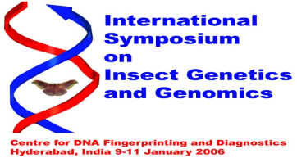


XV International Plant protection Congress



